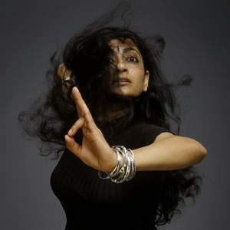
Saturday March 26, 2011
praxis place
1474 N. Milwaukee
Chicago, IL 60622
celiaweissbambara.com

This is a relatively advanced level technique class based on the Odissi classical style of Indian dance, the martial movement form Chhau, and Iyengar style yoga. These forms are deconstructed and then extended to create a contemporary South Asian movement/dance form. We will focus on the exploration of several principles: Articulation of the spine,
Footwork and rhythmic floor patterns,
Hip flexion and torso movement, and breath work.

Please arrive dressed in fitting clothes, preferably shorts, so I
can see your knees. We will dance barefeet, and shoes will not be allowed in class. I will touch students and work with them closely on issues of alignment. If you do not wish to be touched, please inform me ahead of
time so I can respect your privacy.

$15 general and $12 dollars low income/ students.

Pre-registration by e-mail suggested: celiaandchristianbambaradance@gmail.com.

CONTEMPORARY INDIAN DANCE

MASTER CLASS WITH:

Ananya Chatterjea

MARCH 26, 2011: 2-4pm

praxis place presents:

Exploring A Feminine

Feminist Vocabulary

